**ASSIGNMENT 2**

SOFTWARE COMPONENT: PYTHON

CODE:

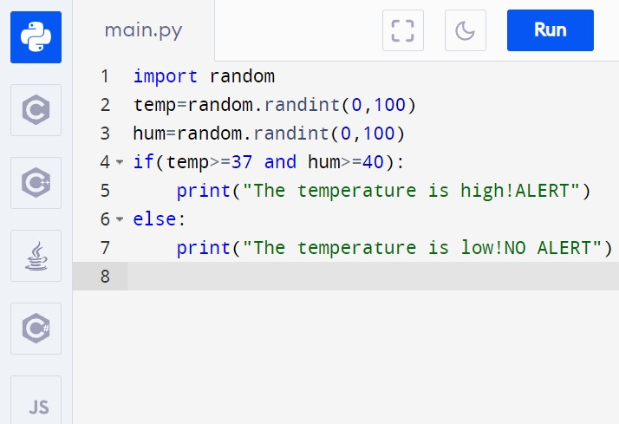

**AFTER COMPILING:**

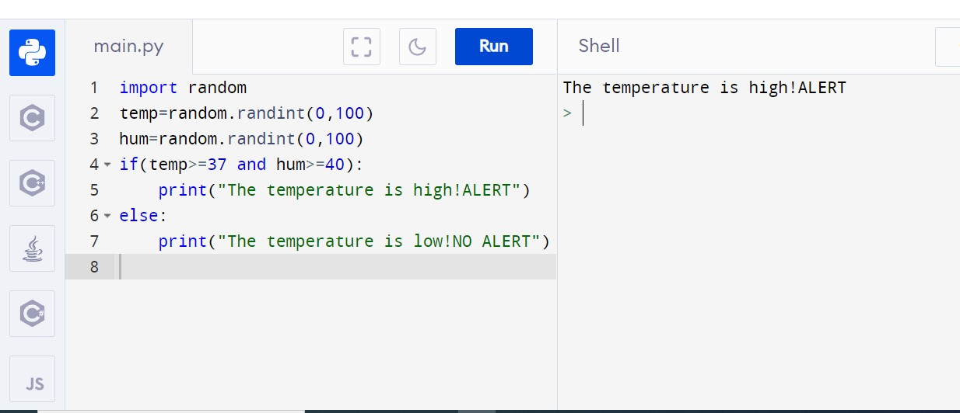

NAME: BEBISHA THERESE.G

REG NO: 963019104002